1. Use the fact that $x^{r}=e^{r\text{ln}(x)}$ and $(e^{x})^{'}=e^{x}$ and the chain rule to prove that $\frac{d}{\text{dx}}\left(x^{r}\right)={\text{rx}}^{r−1}$ for any constant $r$.
2. Below are graphs of $f$ and $g$.
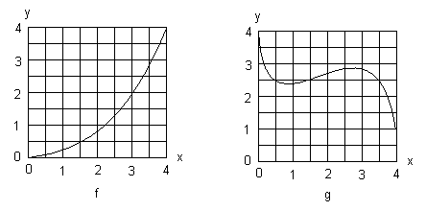

(a) Draw tangent lines to $f$ and $g$ at $x=2$ and estimate their slopes.
(b) Use the graphs of $f$ and $g$ to estimate $h^{'}(2)$, where (i) $h(x)=\frac{1}{2}f(x)$, (ii) $h(x)=f(x)+2g(x)$, (iii) $h(x)=f(x)g(x)$ and (iv) $h(x)=f(g(x))$.

3. Prove that if $f$ has a horizontal tangent at $x=2$ then $f^{2}$ also has a horizontal tangent at $x=2$. Is the converse true? That is, if $f^{2}$ has a horizontal tangent at $x=2$, must $f$ also have a horizontal tangent at $x=2$?

4. Suppose the position of an object at the end of a spring is given by $s(t)=e^{−\text{at}}\text{sin}(\text{bt})$ where $s$ is in centimeters and $t$ is in seconds. Find $a$ and $b$ so that the initial velocity and acceleration are $3$ cm/sec and $−\text{12}$cm/sec² respectively.

